- Internship Name : Data Analysis
- Task Name: Task 2: Conditional Statements and Loops
- Your Name : Shubhangi Naresh Khonde
- Internship Organization :
- Date:

1.Title
Practice Conditional Statements (if-elif-else) and Loops (for, while) in Python.

2. Objective
To understand and practice Python conditional statements and looping structures through simple programming exercises.

3. Tools Used
- Python
- Visual Studio Code
- Jupyter Notebook

4. Introduction:
Python is a high-level programming language widely used in software development, automation, and data analytics. Conditional statements and loops are fundamental concepts that control the flow of program execution.
Conditional statements help make decisions based on specific conditions, while loops allow a block of code to execute repeatedly.

5.Conditional Statements in Python
Conditional statements are used to execute different blocks of code depending on whether a condition is True or False.
Types of conditional statements:
- if statement
- if-else statement
- if-elif-else statement

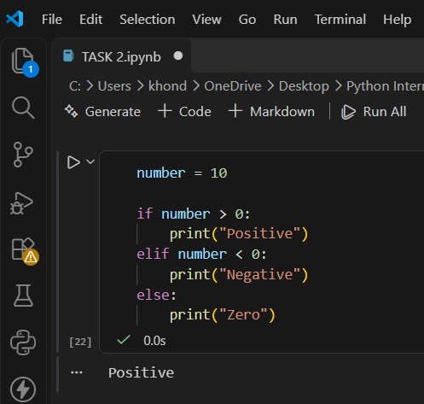
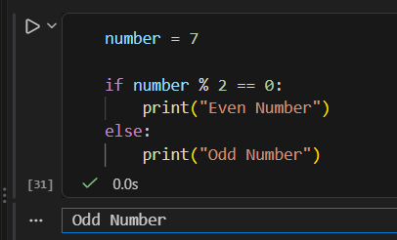

5. Loops in Python
Loops are used to execute a block of code repeatedly. Python provides two commonly used loops: for and while.
For Loop
A for loop is used to iterate over a sequence or a range of values.
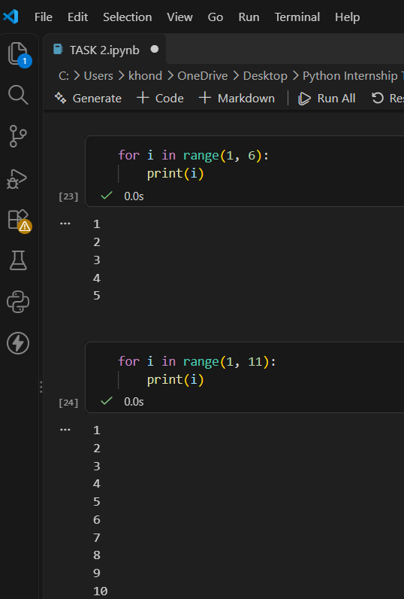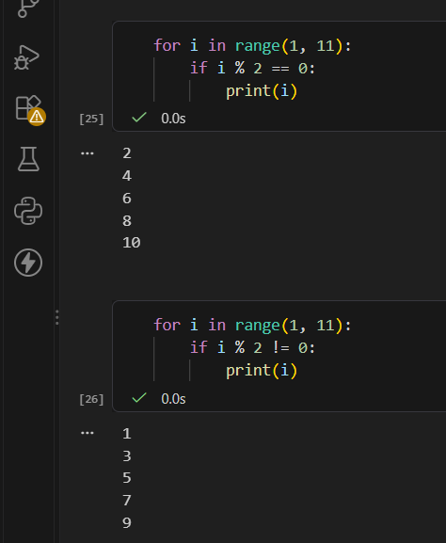
While Loop
A while loop executes a block of code as long as the specified condition remains True.
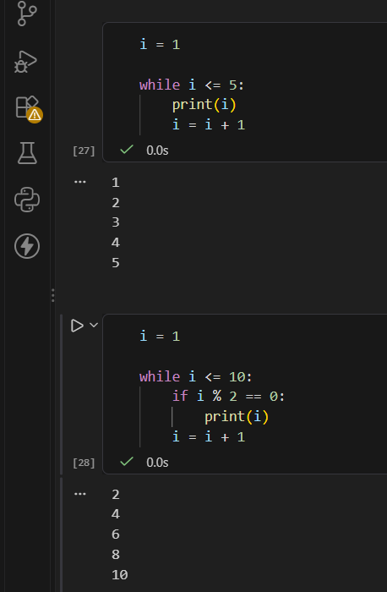

5. Tasks Performed
- Practiced if-else statements to check whether a number is positive, negative, or zero.
- Used if-elif-else to calculate grades based on marks.
- Practiced for loops to print numbers from 1 to 10.
- Used loops and the modulus operator (%) to identify even and odd numbers.
- Practiced while loops to print numbers and even numbers.
- Generated a multiplication table using a for loop.
- Implemented conditional logic to check whether a number is even or odd.

6. Results
All the practice programs were executed successfully. The programs produced the expected outputs for conditional statements, number checking, loops, multiplication tables, and grade calculation.

7. Key Learning
- Understood the use of if, elif, and else.
- Learned how to use for and while loops.
- Practiced the range() function.
- Understood the modulus operator (%) for even and odd number checking.
- Learned how to use conditions inside loops.
- Improved basic Python programming and logical thinking skills.

8. Conclusion
This task provided practical knowledge of Python conditional statements and loops. The exercises helped strengthen programming fundamentals and build a foundation for solving more complex problems in Python.

